OPT8241 EVM hardware

# Sensor

Sensor use OPT8241, drove by OPT9221.

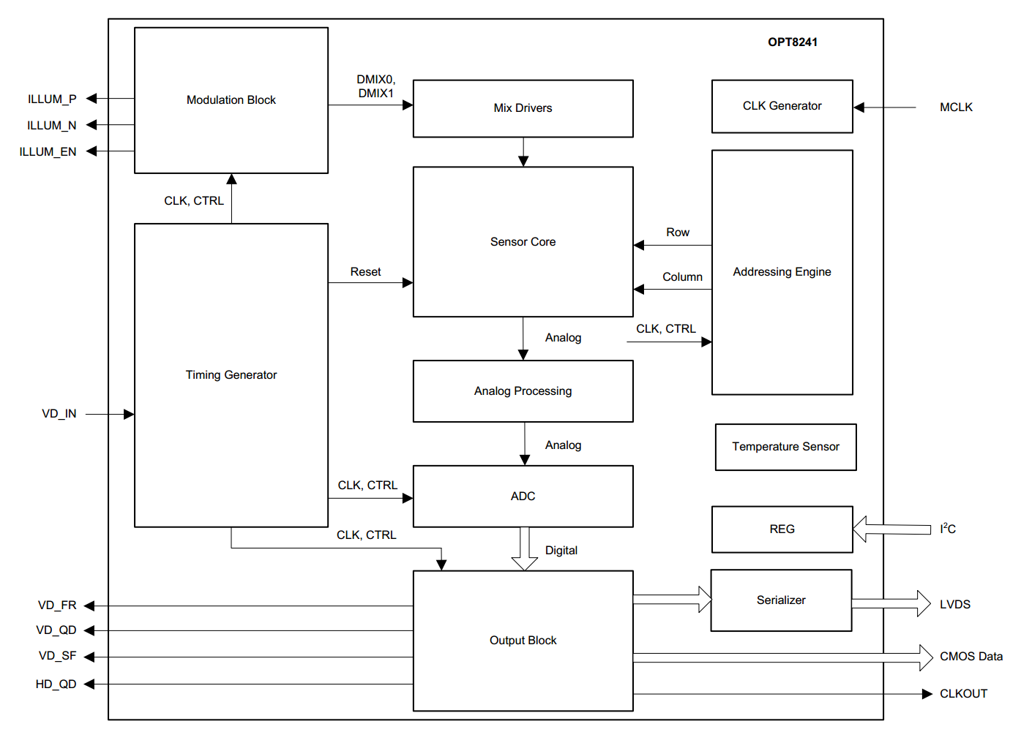

## Output interface

Serializer and LVDS output

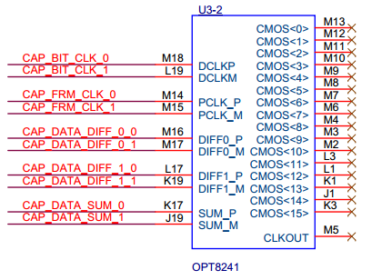

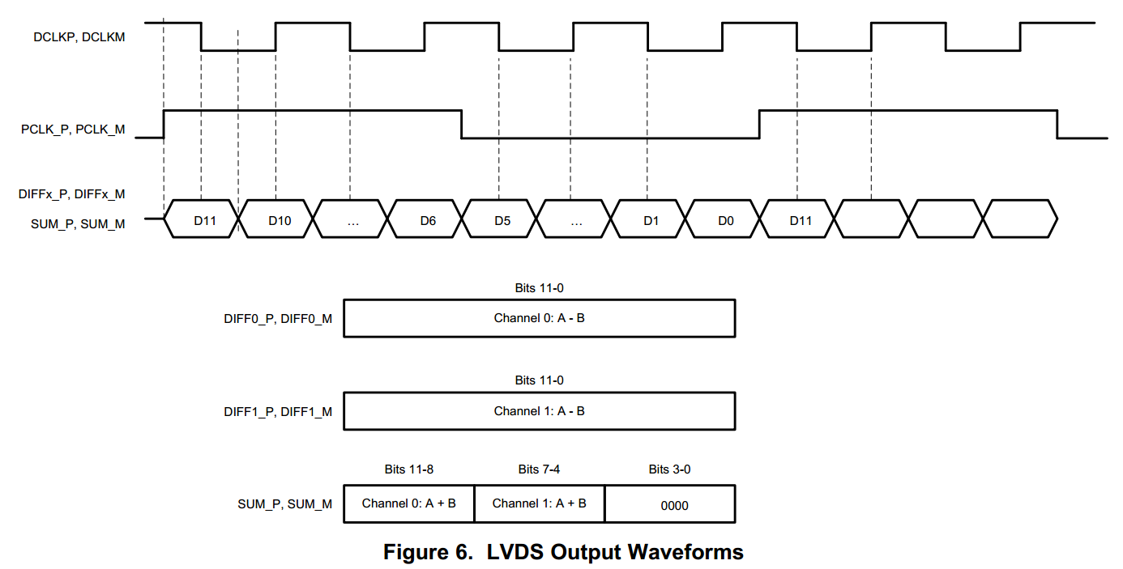

The LVDS interface has no detail description.

## Programming I2C

Use I2C interface, and no detail description, but said by OPT9221 chips.

## ADC module

No detail description, but infer to be a 12 bits ADC.

## Temperature sensor

Range of -25 to 125 C, update frequency at 3ms, read by I2C bus.

## Modulation Block

Produce by OPT8241, and directly send to illumination

## Frame signal

# OPT9221

TOF control chip, match with OPT8241.

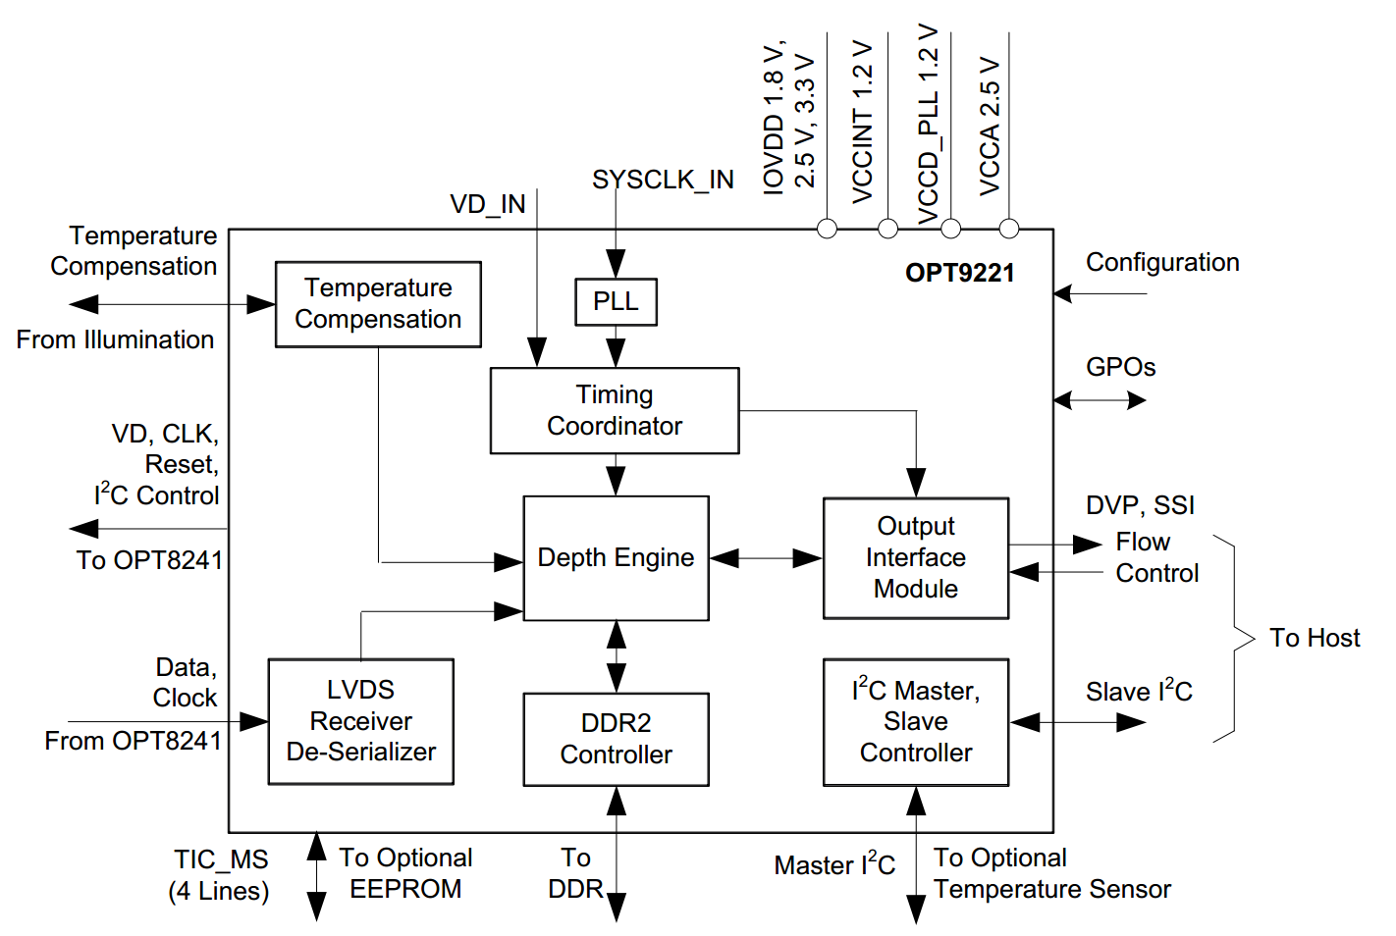

## LVDS receiver and deserializer

No detail description

## Master I2C bus

### Power

Exclusively used for voltage scaling on the DC-DC converters referred to as AVS- or power-I2C interface

### Illumination

## Sensor I2C

No detail description

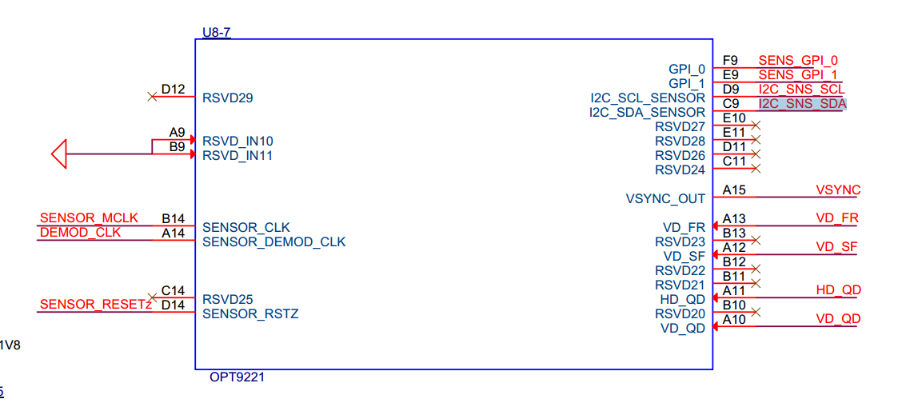

## DDR2

The TFC can support up to 300-MHz DDR2 (150-MHz clock operation). The TFC stores the readout sensor data for all the quads and subframes in the DDR. Once all the necessary data is available, the stored sensor data is retrieved from the DDR to calculate depth data. A minimum of 128 mbits of DDR memory is recommended for correct functionality. The recommended DDR part is Micron MT47H32M16NF-25E:H. 512M DDR2

## USB

Use a Cypress C68053 chip, and connected to **AD9221’s data out ports**. And also connect **to a 4M flash** to update OPT9221’s registers configuration.

## Illumination Path Delay Correction Using Feedback

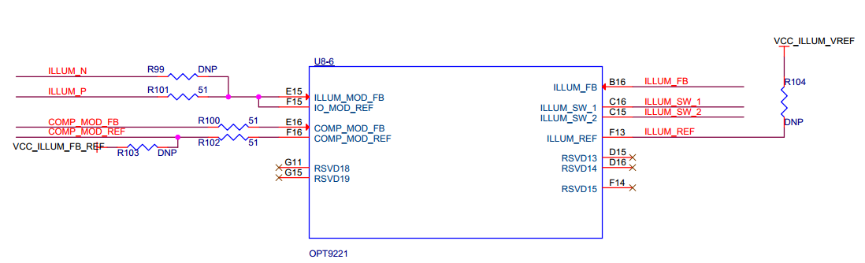

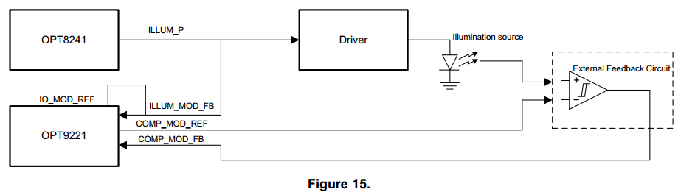

## Programming

### Boot

